INTRODUCTION TO CYBERSECURITY
SUMMATIVE ASSESSMENT MEMO

Module Code | 252901001-KM-01,
NQF Level | 4
Credits | 8
Curriculum Code | 252901001
Qualification Title | Occupational Certificate: Cybersecurity Analyst
SAQA QUAL ID | 118986

Name
Contact Address
Telephone (H)
Telephone (W)
Facsimile
Cellular
E-mail

Note to the learner
This Learner Guide provides a comprehensive overview of the module. It is designed to improve the skills and knowledge of learners, and thus enabling them to effectively and efficiently complete specific tasks.
Entry Requirements

- NQF 4
Provider Accreditation Requirements for the Knowledge Module

Physical Requirements
- The provider must have lesson plans and structured learning material or provide learners with access to structured learning material that addresses all the topics in all the knowledge modules as well as the applied knowledge in the practical skills.
- QCTO/ MICT SETA requirements

Human Resource Requirements:
- Lecturer/learner ratio of 1:20 (Maximum)
- Qualification of lecturer (SME):
    - NQF 6 in industry recognised qualifications with 1 years’ experience in the IT industry
    - CYBERSECURITY vendor certification
- Assessors and moderators: accredited by the MICT SETA
Legal Requirements
- Legal (product) licences to use the software for learning and training
- OHS compliance certificate
- Ethical clearance (where necessary)
Module Purpose
The main focus of the learning in this knowledge module is to build an understanding of fundamentals of various computer and network security threats such as identity theft, credit card fraud, phishing, virus and backdoors, emails hoaxes, loss of confidential information, hacking attacks, and social engineering

Topic elements to be covered include
The learning will enable learners to demonstrate an understanding of:
- KM-01-KT01: Introduction to computer and mobile device security
- KM-01-KT02: Various computer and network security threats
- KM-01-KT03: Identity theft
- KM-01-KT04: Adopting good cybersecurity practices
- KM-01-KT05: Safeguard mobile, media and social networking profiles as user
- KM-01-KT06: Protecting computers, accounts and data as user
- KM-01-KT07: Understand security incidents and reporting

Venue, Date and Time:
Consult your facilitator should there be any changes to the venue, date and/or time.
Refer to your timetable
Assessments

The only way to establish whether you are competent and have accomplished the learning outcomes is through continuous assessments. This assessment process involves interpreting evidence about your ability to perform certain tasks. You will be required to perform certain procedures and tasks during the training programmer and will be assessed on them to certify your competence.

This module includes assessments in the form of self-evaluations/activities and exercises. The exercises, activities and self-assessments will be done in pairs, groups or on your own. These exercises/activities or self-assessments (Learner workbook) must be handed to the facilitator. It will be added to your portfolio of evidence, which will be proof signed by your facilitator that you have successfully performed these tasks.

Listen carefully to the instructions of the facilitator and do the given activities in the time given to you.

KM-01-KT01: Introduction to computer and mobile device security

Question
1
Explain the objectives of computer and mobile device security
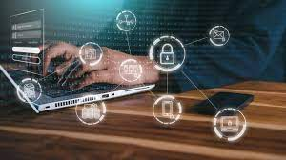
The terms data protection and data privacy are often used interchangeably, but there is an important difference between the two. Data privacy defines who has access to data, while data protection provides tools and policies to actually restrict access to the data. Compliance regulations help ensure that user’s privacy requests are carried out by companies, and companies are responsible to take measures to protect private user data.
Data protection and privacy is typically applied to personal health information (PHI) and personally identifiable information (PII). It plays a vital role in business operations, development, and finances. By protecting data, companies can prevent data breaches, damage to reputation, and can better meet regulatory requirements.
Data protection solutions rely on technologies such as data loss prevention (DLP), storage with built-in data protection, firewalls, encryption, and endpoint protection.

What Is Data Protection and Why Is It Important?
Data protection is a set of strategies and processes you can use to secure the privacy, availability, and integrity of your data. It is sometimes also called data security.
A data protection strategy is vital for any organization that collects, handles, or stores sensitive data. A successful strategy can help prevent data loss, theft, or corruption and can help minimize damage caused in the event of a breach or disaster.
What Are Data Protection Principles?
Data protection principles help protect data and make it available under any circumstances. It covers operational data backup and business continuity/disaster recovery (BCDR) and involves implementing aspects of data management and data availability.
Here are key data management aspects relevant to data protection:
- Data availability—ensuring users can access and use the data required to perform business even when this data is lost or damaged.
- Data lifecycle management—involves automating the transmission of critical data to offline and online storage.
- Information lifecycle management—involves the valuation, cataloging, and protection of information assets from various sources, including facility outages and disruptions, application and user errors, machine failure, and malware and virus attacks.
What Is Data Privacy and Why Is it Important?
Data privacy is a guideline for how data should be collected or handled, based on its sensitivity and importance. Data privacy is typically applied to personal health information (PHI) and personally identifiable information (PII). This includes financial information, medical records, social security or ID numbers, names, birthdates, and contact information.
Data privacy concerns apply to all sensitive information that organizations handle, including that of customers, shareholders, and employees. Often, this information plays a vital role in business operations, development, and finances.
Data privacy helps ensure that sensitive data is only accessible to approved parties. It prevents criminals from being able to maliciously use data and helps ensure that organizations meet regulatory requirements.
What Are Data Protection Regulations?
Data protection regulations govern how certain data types are collected, transmitted, and used. Personal data includes various types of information, including names, photos, email addresses, bank account details, IP addresses of personal computers, and biometric data.
Data protection and privacy regulations vary between countries, states, and industries. For example, China has created a data privacy law that went into effect on June 1, 2017, and the European Union’s (EU) General Data Protection Regulation (GDPR) went into effect during 2018. Non-compliance may result in reputation damages and monetary fines, depending on the violation as instructed by each law and governing entity.
Compliance with one set of regulations does not guarantee compliance with all laws. Additionally, each law contains numerous clauses that may apply to one case but not another, and all regulations are subject to changes. This level of complexity makes it difficult to implement compliance consistently and appropriately.
Data Protection vs Data Privacy
Although both data protection and privacy are important and the two often come together, these terms do not represent the same thing.
One addresses policies, the other mechanisms
Data privacy is focused on defining who has access to data while data protection focuses on applying those restrictions. Data privacy defines the policies that data protection tools and processes employ.
Creating data privacy guidelines does not ensure that unauthorized users don’t have access. Likewise, you can restrict access with data protections while still leaving sensitive data vulnerable. Both are needed to ensure that data remains secure.
Users control privacy, companies ensure protection
Another important distinction between privacy and protection is who is typically in control. For privacy, users can often control how much of their data is shared and with whom. For protection, it is up to the companies handling data to ensure that it remains private. Compliance regulations reflect this difference and are created to help ensure that users’ privacy requests are enacted by companies.

KM-01-KT02: Various computer and network security threats

Question
2
Define and explain how computer and network security threats and attacks work
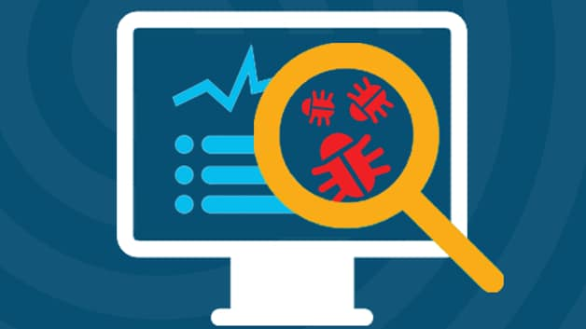
What is Malware?
Malware is intrusive software that is designed to damage and destroy computers and computer systems. Malware is a contraction for “malicious software.” Examples of common malware includes viruses, worms, Trojan viruses, spyware, adware, and ransomware.

Malware, short for “malicious software,” refers to any intrusive software developed by cybercriminals (often called “hackers”) to steal data and damage or destroy computers and computer systems. Examples of common malware include viruses, worms, Trojan viruses, spyware, adware, and ransomware. Recent malware attacks have exfiltrated data in mass amounts.
Types of malware
There are a number of different ways of categorizing malware; the first is by how the malicious software spreads. You've probably heard the words virus, trojan, and worm used interchangeably, but as Symantec explains, they describe three subtly different ways malware can infect target computers:
- A worm is a standalone piece of malicious software that reproduces itself and spreads from computer to computer.
- A virus is a piece of computer code that inserts itself within the code of another standalone program, then forces that program to take malicious action and spread itself.
- A trojan is a program that cannot reproduce itself but masquerades as something the user wants and tricks them into activating it so it can do its damage and spread.
Malware can also be installed on a computer "manually" by the attackers themselves, either by gaining physical access to the computer or using privilege escalation to gain remote administrator access.
Another way to categorize malware is by what it does once it has successfully infected its victim's computers. There are a wide range of potential attack techniques used by malware:
- Spyware is defined by Webroot Cybersecurity as "malware used for the purpose of secretly gathering data on an unsuspecting user." In essence, it spies on your behavior as you use your computer, and on the data you send and receive, usually with the purpose of sending that information to a third party. A keylogger is a specific kind of spyware that records all the keystrokes a user makes—great for stealing passwords.
- A rootkit is, as described by TechTarget, "a program or, more often, a collection of software tools that gives a threat actor remote access to and control over a computer or other system." It gets its name because it's a kit of tools that (generally illicitly) gain root access (administrator-level control, in Unix terms) over the target system, and use that power to hide their presence.
- Adware is malware that forces your browser to redirect to web advertisements, which often themselves seek to download further, even more malicious software. Adware often piggybacks onto tempting "free" programs like games or browser extensions.
- Ransomware is a flavor of malware that encrypts your hard drive's files and demands a payment, usually in Bitcoin, in exchange for the decryption key. Several high-profile malware outbreaks of the last few years, such as Petya, are ransomware. Without the decryption key, it's mathematically impossible for victims to regain access to their files. So-called scareware is a sort of shadow version of ransomware; it claims to have taken control of your computer and demands a ransom, but actually is just using tricks like browser redirect loops to make it seem as if it's done more damage than it really has, and unlike ransomware can be relatively easily disabled.
- Cryptojacking is another way attackers can force you to supply them with Bitcoin—only it works without you necessarily knowing. The crypto mining malware infects your computer and uses your CPU cycles to mine Bitcoin for your attacker's profit. The mining software may run in the background on your operating system or even as JavaScript in a browser window.
- Malvertising is the use of legitimate ads or ad networks to covertly deliver malware to unsuspecting users’ computers. For example, a cybercriminal might pay to place an ad on a legitimate website. When a user clicks on the ad, code in the ad either redirects them to a malicious website or installs malware on their computer. In some cases, the malware embedded in an ad might execute automatically without any action from the user, a technique referred to as a “drive-by download.”
Any specific piece of malware has both a means of infection and a behavioral category. So, for instance, WannaCry is a ransomware worm. And a particular piece of malware might have different forms with different attack vectors: for instance, the Emotet banking malware has been spotted in the wild as both a trojan and a worm.

How do I protect my network against malware?
Typically, businesses focus on preventative tools to stop breaches. By securing the perimeter, businesses assume they are safe. Some advanced malware, however, will eventually make their way into your network. As a result, it is crucial to deploy technologies that continually monitor and detect malware that has evaded perimeter defenses. Sufficient advanced malware protection requires multiple layers of safeguards along with high-level network visibility and intelligence.
How do I detect and respond to malware?
Malware will inevitably penetrate your network. You must have defenses that provide significant visibility and breach detection. In order to remove malware, you must be able to identify malicious actors quickly. This requires constant network scanning. Once the threat is identified, you must remove the malware from your network. Today's antivirus products are not enough to protect against advanced cyber threats

KM-01-KT03: Identity theft

Question
3
Explain two types of identity theft and how to mitigate them
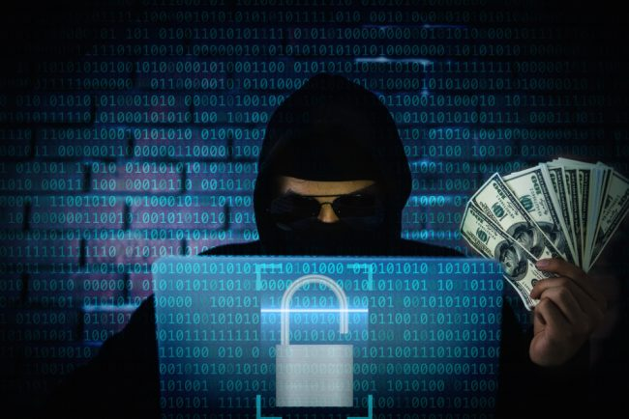
Financial identity theft
Financial identity theft is when one person uses another’s personal data for financial benefit. This is the most common form of identity theft (including the credit card example described above). Financial identity theft can take multiple forms, including:
- Fraudsters may use your credit card information to buy things. We all love to shop online — even criminals. Unfortunately, this issue has become especially prevalent thanks to online shopping during the COVID-19 pandemic.
- Hackers may steal funds from your bank account. Sometimes, the amount might be so small that it seems inconsequential, totaling just a few dollars. However, criminals can rack up millions in damages if they target enough people in this way.
- Criminals may open new accounts using your Social Security number and other data. For example, a person may use your data to open a new line of credit. They then run through the credit line, leaving you to foot the bill.
The good news is that it’s easy to protect yourself against financial identity theft by checking your bank accounts, credit card statements, and bills. If you see an unexplained charge, contact your credit card company or bank immediately to report it. Also, check your credit report for changes in your score. An unexplained decrease in your score could mean fraudulent activity.
Another idea is to place a one-year fraud alert on your credit reports to keep people from opening new accounts in your name. This encourages creditors and lenders to take extra precautions to verify your identity before granting any loans or credit increases. You can also place a security freeze on your credit report, which blocks others from accessing it to extend credit.
Medical identity theft
This might not seem like a real form of identity theft, but it happens. Medical identity theft is when a criminal poses as another person to obtain health care services. In fact, fraudsters may use your name and insurance information to:
- Get prescriptions for drugs.
- Access medical services, from checkups to costly surgeries.
- Obtain medical devices and supplies, such as wheelchairs or hearing aids.
This can result in you having bills for prescriptions, services, or devices you didn’t need, ask for, or even receive. Your health care and insurance records may even have these things added to them. An inaccurate medical record can make it harder for you to get the care you need in the future and even impact insurance coverage.
Fortunately, you can help minimize the risk of medical identity theft by regularly reviewing your medical claims. Contact your insurer if you see unfamiliar procedures, prescriptions, or services. You’ll also want to let your health care provider know so that they can ensure your medical files are correct.
Criminal identity theft
Criminal identity theft occurs when a person arrested by law enforcement uses someone else’s name instead of providing theirs. They might be able to pass this off by creating a fake ID or using a stolen ID, like your driver’s license, to show to the police. This type of fraud can be difficult to detect until the consequences are evident, like:
- You receive a court summons. For example, the courts may issue a summons if a criminal uses your ID for unpaid parking tickets.
- A bench warrant is issued for your arrest. Unresolved problems like unpaid parking tickets can also result in a judge issuing a bench warrant. You may then be taken into custody at any time, even during a routine traffic stop.
- A background check is issued. Sometimes, police will keep an identity theft victim in their database, noting it as an alias for the real criminal. This can result in a false criminal record showing up on your background check. This can cause problems with potential landlords and employers.
You can help protect yourself against criminal identity theft by safeguarding your ID. If your license or state-issued ID is lost or stolen, report it to the local Department of Motor Vehicles (DMV) and law enforcement. Also, limit the information you share online (and encourage family members to do the same). For example, if your teen got their first driver’s license and wants to share a pic of it on social media, explain why this isn’t a good idea.
Synthetic identity theft
As one of the fastest-growing types of financial crime in the U.S., synthetic identity theft involves creating fake identities using real people’s information. Fraudsters may use data like birthdates, addresses, and Social Security numbers from real people, blending them to create a fake profile. They can then use this persona to apply for loans or credit cards or commit other financial crimes. Kids and older adults tend to be vulnerable to this type of fraud since they rarely use their SSNs.
The most important thing about synthetic identity theft is knowing the signs and acting fast. Keep an eye out for any mail with your address on it but addressed to a different name and phone calls or mail about new credit accounts. You can further protect yourself by regularly checking your credit reports for unexplained changes and placing a security freeze on them.
There are also identity monitoring services available, which scan the internet, including the dark web, for breached Social Security numbers. If you suspect you or a loved one is the victim of synthetic identity theft, contact the relevant financial institutions to alert them.

KM-01-KT04: Adopting good cybersecurity practices

Question
4
Explain of the importance of updating software when they become old to newer versions which tend to have more security upgrades
It always feels like new updates come at the most inconvenient times. The easiest option is normally to ignore.
Of course, they can be annoying but they aren’t just there for the fun of it. Turns out there’s a lot of good reasons to not put off software updates. They’re mostly free so you don’t have to worry about cost, you just have to set aside the time to do it.
With more and more people using cloud-based software, updates are regularly delivered to your computer, ready for you to install.
It’s also important to make sure non-cloud-based software is updated to the latest version or edition. Not least because you don’t tend to get reminders for these.
Below, we’ve got 4 of the big reasons why you should always keep your software up to date. If you would like some further assistance, our software consultancy team are always on hand to help too.

Better software
One reason to update to the latest version or a new edition is simply that you, the user, get a better program.
Software companies are constantly improving their products. Adding new features, improving the user journey and sharpening the functionality so that it achieves its end goal in the most efficient way possible.
The barrier to this of course is that you can get used to how a certain version of a program works. It can be hard to move on from something you’re used to.
But the chances are the new one is probably going to be better. Although initially it may seem illogical to start using something totally new, it’s probably for the best in the long run.
It doesn’t always work like that but generally it’s worth trusting that software developers are trying to do a good job and develop something that works better.

Fix bugs
Those pesky bugs. Not the creepy crawly variety but the little niggles and problems that are often found in software of any kind.
Most bugs you’ll never even notice but the reality is they’ve all got them.
It’s virtually impossible to release a 100% perfectly working product in time for launch so most of the time, the software will be released and then patched up later.
In some cases, one small bug can have a ripple effect causing a slew of related issues.
The good news is developers are always aiming to improve and fix flaws. In order to iron out the issues and have as smoothly running system as you can, it’s important to update and add those all-important bug fixes.

KM-01-KT05: Safeguard mobile, media and social networking profiles as user

Question
5
Discuss mechanisms to safeguard mobile and media devices
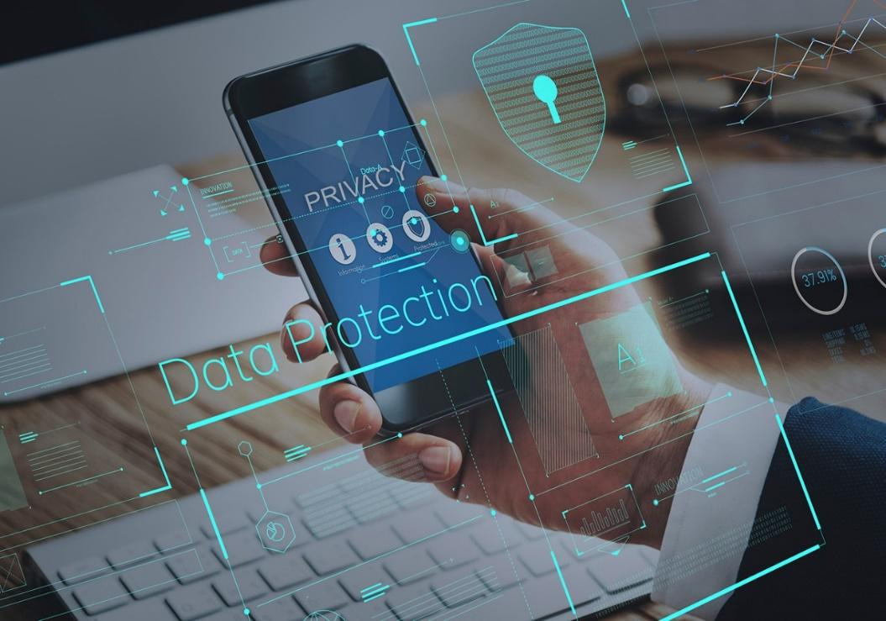
The rapidly changing technology and portability of mobile devices have forced people to heavily rely on those products. With their increased functionalities, mobile devices carry out a number of our day-to-day activities, such as surfing the web, booking appointments, setting up reminders, sharing files, instant messaging, video calling, and even mobile banking. Given all these functionalities, mobile devices are vulnerable to online threats and are also susceptible to physical attacks due to their portability. Some of the security threats include malware specifically designed for mobile devices i.e. worms and spyware, unauthorized access, phishing, and theft. But not all is lost. Here are some practical steps that will help you minimize the exposure of your mobile device to digital threats.
1. Use strong passwords/biometrics
Strong passwords coupled with biometric features, such as fingerprint authenticators, make unauthorized access nearly impossible. Your passwords should be eight or more characters long and contain alphanumeric characters. If your mobile device allows two-factor authentication, don’t hesitate to use it. You don’t want to be subject to unforeseen attacks. The complexities of your passwords in other apps might tempt you to store them in a similar way a browser does – that is, using the 'remember me feature.' This feature should be avoided at all costs since it only increases the chances of your password getting spoofed. Alternatively, if you lose your device, another person might gain full access to it. Furthermore, don’t forget to change your password from time to time (at least every three months).
2. Ensure public or free Wi-Fi is protected
Everybody loves free Wi-Fi, especially when the data plan is inexpensive. But cheap can turn expensive in a very devastating manner. That's because most of the free Wi-Fi points are not encrypted. These open networks allow malicious people to eavesdrop on the network traffic and easily get your passwords, usernames and other sensitive information. That threat isn't going anywhere anytime soon, either. To protect against Wi-Fi hacking, use applications that secure your connection or at least tell you the status of the Wi-Fi to which you are connected. WPA (Wi-Fi Protected Access) is more secure compared to WEP (Wired Equivalent Privacy). As a matter of being cautious, you should also turn off wireless connectivity (Wi-Fi and Bluetooth) when you are not using them. Not only will this help avoid automatic connection to unencrypted networks but also save your battery.
3. Utilize VPN
If you’re not sure about the security status of the network to which you’re connected, using VPN (Virtual Private Network) client is mandatory. A VPN will enable you to connect to a network securely. At the same time, any browsing activity you do on the public Wi-Fi will be shielded from prying eyes. It is also useful when accessing sites that are less secure. Non-HTTPS sites are visible to anyone who knows how to use networking and vulnerability tools. These sites are prone to MITM (Man-in-the-middle) attacks, which pave a way to eavesdropping and password sniffing. You really need to have a new mindset when it comes to fighting cybercrime.
4. Encrypt your device
Most mobile devices are bundled with a built-in encryption feature. Encryption is the process of making data unreadable. Decryption is converting the unreadable data into normal data. This is important in case of theft, and it prevents unauthorized access. You simply need to locate this feature on your mobile device and enter a password to encrypt your device. This process may take time depending on the size of your data. The bigger the data, the more time it will take. Most importantly, you need to remember the encryption password because it's required every time you want to use your mobile device. Also, as a fail-safe, consider backing up your data since some mobile devices will automatically erase everything if the wrong encryption password is entered incorrectly after a number of times.
5. Install an Antivirus application
The files you download and the apps you install on your mobile device might be packed with malicious code. Once launched, this code could send your data to hackers, thereby making you unsecured and robbing you of your privacy. To avoid that, installing a reputable antivirus application will guarantee your security. Some antivirus applications also offer more functionalities, such as erasing your data if you lose your mobile device, tracking and blocking unknown callers who might be a threat, and telling you which applications are not safe. In addition, they offer to clear your browsing history and delete cookies. Cookies are small software tokens that store your login information that might be leaked if someone malicious gets to them.

KM-01-KT06: Protecting computers, accounts and data as user

Question
6
Elaborate the importance of securing email communications
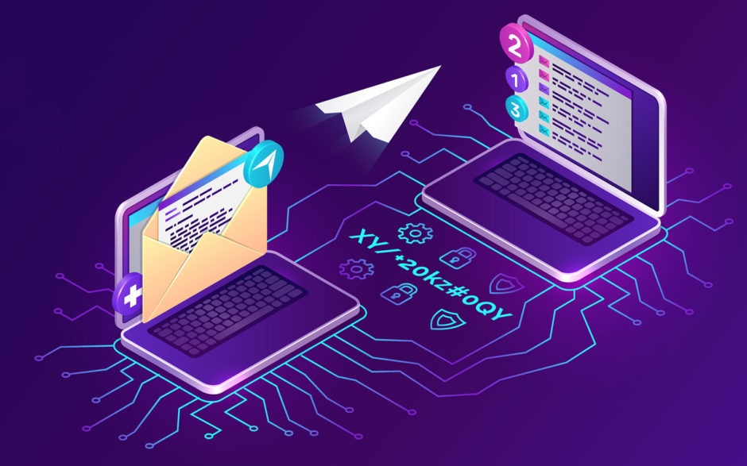
Email security can be defined as the use of various techniques to keep sensitive information in email communication and accounts secure. These precautions are taken chiefly against unauthorized access, loss, or compromise. It allows an individual or an organization to protect the overall access to one or more email addresses or accounts.

Email security safeguards the content of an email account or service that generally serves as a popular medium for the spread of malware, spam, and phishing attacks. This is usually done using deceptive messages to entice recipients to divulge sensitive information, open attachments, or click on hyperlinks that install malware on the victim’s device.
Stopping attacks at the entry point:

Email is also a common entry point for attackers looking to gain a foothold in an enterprise network and breach valuable business data. Hence, email security is necessary for both individual and business email accounts, and there are multiple measures organizations should take to enhance email security. Some of the proactive email security measures, from an end user’s standpoint, include:

- Strong passwords
- Password rotations
- Spam filters
- Desktop-based anti-virus or anti-spam application
Similarly, a service provider ensures email security by using strong passwords and access-control mechanisms on an email server. Here, the email messages are encrypted and digitally signed as they are placed in the inbox or are in transit to or from a subscriber’s email address.

The service provider also implements firewall and software-based spam filtering applications to restrict unsolicited, untrustworthy, and malicious email messages from being delivered to a user’s inbox.

Why Is Email Security Important?

Email is a popular attack vector. Therefore, enterprises and individuals must secure their email accounts against common attacks and attempt to gain unauthorized access to the communications’ accounts or content. Email security is significant due to the following plausible reasons:

Email is a common target for cyber-criminals

The first thing that employees get as soon as they join any firm is their official email account. The employees use their respective email IDs to access the company information and communicate with fellow employees daily. Every official communication to or from the company uses email as a medium.

Therefore, when employees work remotely, as observed in the COVID-19 pandemic situation, they tend to use their official emails for almost all communication. Such communications are vulnerable, and the employees are at the risk of being attacked by cyber-criminals. Cyber-criminals often use phishing, baits, social engineering, and many other types of attacks to exploit cracks in the security system.

A small loophole can affect the entire organization

A small loophole in an email’s security can allow deadly malware or spyware to sneak into the entire communication network, wreaking havoc in the entire organization. The situation worsens when the organization’s network is hit by deadly ransomware.

Even seasoned professionals and experienced employees fall victim to such tactics. These cyber thieves may also leak sensitive information by bringing it into the public domain or by selling it to bidders in the case of a personal vendetta.

Crucial for organizations to protect sensitive information

The company’s confidential information may include highly sensitive information that can be used against the organization or for criminal purposes. Cyber-criminals can also target day-to-day communication and change messages, which can create miscommunication and compel the communicators (the employees) to release or hide relevant information.

Such forgery may result in identity theft that can ultimately cause a breach of sensitive information. Both employees and organizations have to bear in mind that cyber-criminals only need a thin crack in security to jeopardize the entire workflow.

KM-01-KT07: Understand security incidents and reporting

Question
7
Explain what is data backup
Backing up data is critical to ensuring system integrity, but if done incorrectly, it can exacerbate already-existing security issues. Fortunately, there are a number of best practices that can be followed.
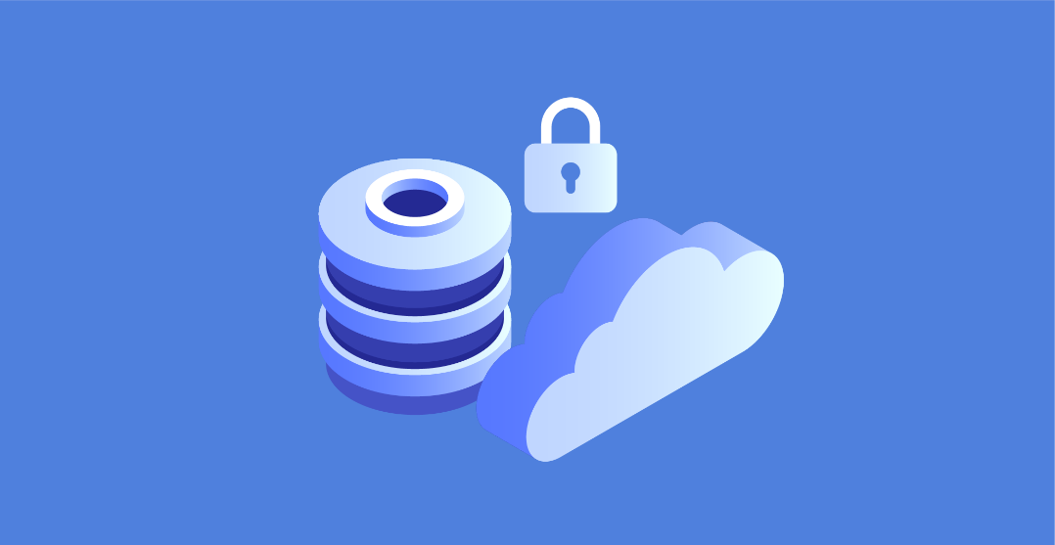
In order to keep your data safe and secure, you need to have regular data backups. However, these backups are often the source of many security problems. In fact, a large number of security breaches can be traced back to the mismanagement of data backups. A lack of adequate data backup controls is evident in the headlines and security surveys that are published. There's nothing wrong with using best practices when developing an enterprise data backup strategy.
Millions of sensitive business records have been compromised in backup-related mistakes over the last few years, according to recent reports. Indeed, these are just the incidents that have been publicly reported. Confidential information, including intellectual property, is no less vulnerable to data backup-related breaches than other types of sensitive data. Without a solid back-up plan in place when things go wrong, security is the first thing on the shark’s menu.
As long as there is a process for replicating sensitive data, many storage professionals believe that their organization is safe. However, this is only half of the battle. A new set of dangers arises from what can be done with data backups, which are often overlooked. Because of this, it is essential to incorporate secure data backup guidelines into the overall enterprise information security strategy.
Here are 10 ways to keep your data backups safe and secure from threats like ransomware, malicious insiders, and external hackers, both locally and in the cloud:
Make sure you have a backup plan in place
It is important to make sure your security policies include backup systems. Access control, system monitoring, and malware protection all have a direct impact on data backups.
Incorporate backup systems into your disaster recovery plan
Your disaster recovery and incident response plans should include a backup of your computer files and other important information. A ransomware outbreak, an employee break-in, or an environmental event such as a flood or hurricane can all compromise or destroy a company's data backups. If you don't have a plan in place for what to do if and when the time comes, your backups could be harmed.
In order to protect data backups, restrict access to them
Only those who need to be involved in the backup process should be given access rights. Software and data backups are no exception here either. Systems that provide backup access, whether on-premises or in the cloud, should not be undervalued.

